**Summary note of the phonon olympics entry for Germanium**

Author: Terumasa TADANO (NIMS)

Date: Jan. 27, 2022.

Codes: VASP 6.2.1 + ALAMODE 1.3.0 (some new features of dev branch are also tested)

Compilers: Intel Compiler version 20.0.2.254 + Intel MKL

Compile flags: -O2 for ALAMODE, -O2 -xHOST for VASP

MPI library: HPE MPI 2.21

Computer Resource: NIMS simulator (Intel Xeon Platinum 8268 24core 2.9 GHz x 2 / node)

**1. Structure - summary**

The calculations were performed using VASP code with the following input parameters:

```

PREC = Accurate

ENCUT = 300

EDIFF = 1.0e–8

EDIFFG = –1.0e–4

ISMEAR = 2

SIGMA = 0.2

ALGO= Normal

LREAL = .FALSE.

ADDGRID = .TRUE.

LWAVE = .FALSE.

LCHARG = .FALSE.

ICHARG= 2

ISTART=0

NELM=200

NPAR = 8

ISIF = 3

IBRION = 2

NSW = 100

POTIM = 0.1

GGA = PS

```

As shown in the tables and figures below, the lattice constant obtained from the variable-cell relaxation ( ISIF=3 ) appears to reach convergence at 8x8x8 k points and ENCUT=300 . So, I have chosen

ENCUT = 300

8x8x8 k points for primitive

a = 5.7019 Angstrom

for the following electronic/phonon calculations.

Note: The k point may be denser for supercell calculations as described in the phonon dispersion part.

|  | ENCUT (eV) | energy (eV) | lattice constant (Ang.) | ionic_steps | cores | Elapsed time (sec) |  |
| --- | --- | --- | --- | --- | --- | --- | --- |
| 0 | 200 | –9.789082 | 5.70080 | 4 | 96 | 13.557 |
| 1 | 250 | –9.790439 | 5.70250 | 3 | 96 | 8.925 |
| 2 | 300 | –9.791442 | 5.70199 | 4 | 96 | 8.242 |
| 3 | 350 | –9.792332 | 5.70202 | 3 | 96 | 7.098 |
| 4 | 400 | –9.792902 | 5.70231 | 3 | 96 | 8.194 |
| 5 | 450 | –9.793038 | 5.70243 | 3 | 96 | 8.021 |
| 6 | 500 | –9.793123 | 5.70239 | 3 | 96 | 7.977 |
| 7 | 550 | –9.793240 | 5.70232 | 3 | 96 | 7.604 |
| 8 | 600 | –9.793352 | 5.70232 | 1 | 96 | 5.874 |
| 9 | 650 | –9.793414 | 5.70238 | 3 | 96 | 8.895 |
| 10 | 700 | –9.793437 | 5.70238 | 1 | 96 | 6.954 |
| 11 | 750 | –9.793448 | 5.70238 | 1 | 96 | 7.419 |
| 12 | 800 | –9.793466 | 5.70237 | 2 | 96 | 9.082 |
| 13 | 850 | –9.793488 | 5.70237 | 2 | 96 | 8.599 |
| 14 | 900 | –9.793506 | 5.70237 | 1 | 96 | 7.685 |
| 15 | 950 | –9.793521 | 5.70232 | 6 | 96 | 14.759 |
| 16 | 1000 | –9.793547 | 5.70232 | 1 | 96 | 7.895 |

|  | # k points along each axis | energy (eV) | lattice constant (Ang.) | ionic_steps | cores | Elapsed time (sec) |  |
| --- | --- | --- | --- | --- | --- | --- | --- |
| 0 | 5 | –9.687007 | 5.71213 | 3 | 96 | 2.227 |
| 1 | 6 | –9.791674 | 5.70153 | 4 | 96 | 3.766 |
| 2 | 7 | –9.770145 | 5.70430 | 3 | 96 | 2.577 |
| 3 | 8 | –9.792838 | 5.70229 | 5 | 96 | 5.862 |
| 4 | 9 | –9.786484 | 5.70219 | 8 | 96 | 4.549 |
| 5 | 10 | –9.793064 | 5.70242 | 3 | 96 | 5.923 |
| 6 | 11 | –9.790658 | 5.70225 | 12 | 96 | 7.895 |
| 7 | 12 | –9.793123 | 5.70239 | 3 | 96 | 7.977 |
| 8 | 13 | –9.792114 | 5.70253 | 3 | 96 | 4.833 |
| 9 | 14 | –9.793118 | 5.70228 | 7 | 96 | 17.006 |
| 10 | 15 | –9.792685 | 5.70258 | 3 | 96 | 5.848 |
| 11 | 16 | –9.793104 | 5.70224 | 7 | 96 | 25.237 |
| 12 | 17 | –9.792922 | 5.70256 | 3 | 96 | 7.545 |
| 13 | 18 | –9.793097 | 5.70224 | 7 | 96 | 36.111 |
| 14 | 19 | –9.793031 | 5.70253 | 3 | 96 | 9.380 |
| 15 | 20 | –9.793095 | 5.70225 | 7 | 96 | 50.120 |

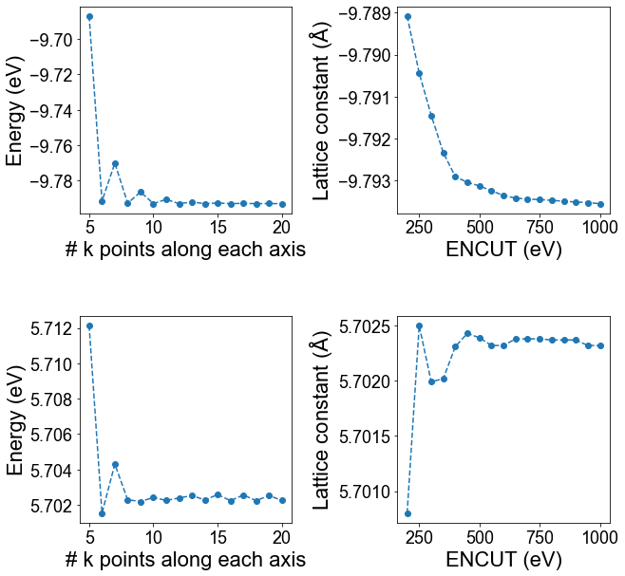

png

**2. Electronic - summary**

The electronic band dispersion obtained from the 8x8x8 k points agrees well with the result obtained from the denser 12x12x12 k points. So, we conclude that 8x8x8 kpoints was accurate enough.

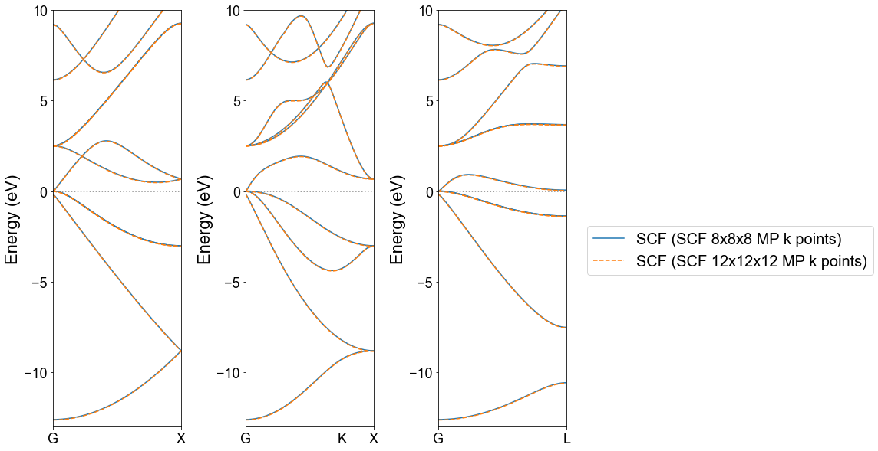

png

**3.1 Harmonic - convergence at G, X, and L points**

The phonon frequencies at Gamma (0,0,0), X(0.5, 0.5, 0), and L(0.5, 0.5, 0.5) points are calculated using the following conditions:

2x2x2 supercell (16 atoms)

displacement magnitude : 0.01 Angstrom

make full use of symmetry (permutation, space group)

consider ASR as constraint

Fit displacement-force dataset by ordinary least squares

The results of convergence check with respect to ENCUT are shown in the table and figure. As ENCUT increases, the frequencies tend to increase gradually and eventually reach convergence at ENCUT ~ 600 . Still, our initial choice of ENCUT = 300 already gives very reasonable results and meets the target accuracy of < 0.1 THz.

|  | ENCUT (eV) | f_G1 | f_X1 | f_X2 | f_X3 | f_L1 | f_L2 | f_L3 | f_L4 | k mesh style | k mesh | k mesh shift |  |
| --- | --- | --- | --- | --- | --- | --- | --- | --- | --- | --- | --- | --- | --- |
| 0 | 200 | 8.4898 | 2.1055 | 6.9020 | 7.8668 | 1.7014 | 6.3573 | 6.9656 | 8.2978 | Monkhorst | [4, 4, 4] | [0.5, 0.5, 0.5] |
| 1 | 250 | 8.4916 | 2.1038 | 6.9009 | 7.8671 | 1.7006 | 6.3565 | 6.9641 | 8.2988 | Monkhorst | [4, 4, 4] | [0.5, 0.5, 0.5] |
| 2 | 300 | 8.4926 | 2.1046 | 6.9020 | 7.8683 | 1.7010 | 6.3575 | 6.9656 | 8.2999 | Monkhorst | [4, 4, 4] | [0.5, 0.5, 0.5] |
| 3 | 350 | 8.4935 | 2.1031 | 6.9020 | 7.8690 | 1.6998 | 6.3571 | 6.9658 | 8.3007 | Monkhorst | [4, 4, 4] | [0.5, 0.5, 0.5] |
| 4 | 400 | 8.4943 | 2.1048 | 6.9028 | 7.8697 | 1.7010 | 6.3581 | 6.9667 | 8.3014 | Monkhorst | [4, 4, 4] | [0.5, 0.5, 0.5] |
| 5 | 450 | 8.4942 | 2.1047 | 6.9025 | 7.8695 | 1.7010 | 6.3578 | 6.9662 | 8.3012 | Monkhorst | [4, 4, 4] | [0.5, 0.5, 0.5] |
| 6 | 500 | 8.4944 | 2.1044 | 6.9026 | 7.8697 | 1.7007 | 6.3577 | 6.9663 | 8.3014 | Monkhorst | [4, 4, 4] | [0.5, 0.5, 0.5] |
| 7 | 550 | 8.4948 | 2.1047 | 6.9029 | 7.8701 | 1.7009 | 6.3581 | 6.9668 | 8.3018 | Monkhorst | [4, 4, 4] | [0.5, 0.5, 0.5] |
| 8 | 600 | 8.4949 | 2.1049 | 6.9031 | 7.8703 | 1.7010 | 6.3582 | 6.9670 | 8.3020 | Monkhorst | [4, 4, 4] | [0.5, 0.5, 0.5] |
| 9 | 650 | 8.4950 | 2.1052 | 6.9032 | 7.8703 | 1.7013 | 6.3584 | 6.9670 | 8.3020 | Monkhorst | [4, 4, 4] | [0.5, 0.5, 0.5] |
| 10 | 700 | 8.4949 | 2.1052 | 6.9031 | 7.8702 | 1.7012 | 6.3583 | 6.9669 | 8.3020 | Monkhorst | [4, 4, 4] | [0.5, 0.5, 0.5] |
| 11 | 750 | 8.4950 | 2.1053 | 6.9031 | 7.8703 | 1.7013 | 6.3583 | 6.9670 | 8.3020 | Monkhorst | [4, 4, 4] | [0.5, 0.5, 0.5] |
| 12 | 800 | 8.4951 | 2.1052 | 6.9031 | 7.8703 | 1.7013 | 6.3583 | 6.9670 | 8.3021 | Monkhorst | [4, 4, 4] | [0.5, 0.5, 0.5] |

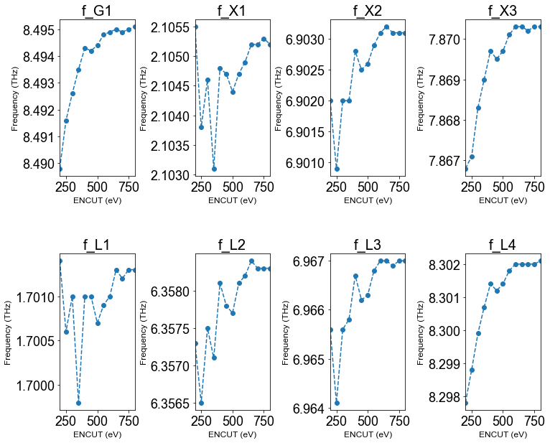

png

**3.2 Harmonic - convergence of dispersion**

To examine the convergence of phonon dispersion curves, we have performed phonon calculations using various supercells and k points as summarized below:

|  | Supercell (SC) size | # atoms in SC | ENCUT | k mesh style | k mesh | k mesh shift | # of cores | Total CPU time (sec.) | Wall time (sec.) | magnitude of\ndisplacement (Ang.) |  |
| --- | --- | --- | --- | --- | --- | --- | --- | --- | --- | --- | --- |
| 0 | 222 | 16 | 300.0 | Monkhorst | [4, 4, 4] | [0.5, 0.5, 0.5] | 96 | 13.830 | 14.293 | 0.01 |
| 1 | 222conv | 64 | 300.0 | Gamma | [3, 3, 3] | [0.0, 0.0, 0.0] | 96 | 33.521 | 35.776 | 0.01 |
| 2 | 222conv_fine | 64 | 300.0 | Monkhorst | [4, 4, 4] | [0.5, 0.5, 0.5] | 96 | 48.116 | 51.821 | 0.01 |
| 3 | 444 | 128 | 300.0 | Monkhorst | [2, 2, 2] | [0.5, 0.5, 0.5] | 96 | 160.485 | 166.963 | 0.01 |
| 4 | 333conv | 216 | 300.0 | Monkhorst | [2, 2, 2] | [0.5, 0.5, 0.5] | 96 | 183.162 | 186.060 | 0.01 |
| 5 | 444conv | 512 | 300.0 | Gamma | [1, 1, 1] | [0.0, 0.0, 0.0] | 96 | 608.538 | 612.415 | 0.01 |
| 6 | 444conv_fine | 512 | 300.0 | Monkhorst | [2, 2, 2] | [0.5, 0.5, 0.5] | 192 | 1143.610 | 1150.086 | 0.01 |

The results are plotted in the figure below.

For the supercell size, 222 conventional ( 222 conv. denser k ) appears to be adequate, but using a larger conventional supercell ( 333 conv. or 444 conv. denser k ) slightly improves the accuracy. Also, when the k mesh shift is 0 (or when the k mesh density is not enough?), the TO frequency at Gamma was underestimated. So, we will use the “denser k” option when necessary.

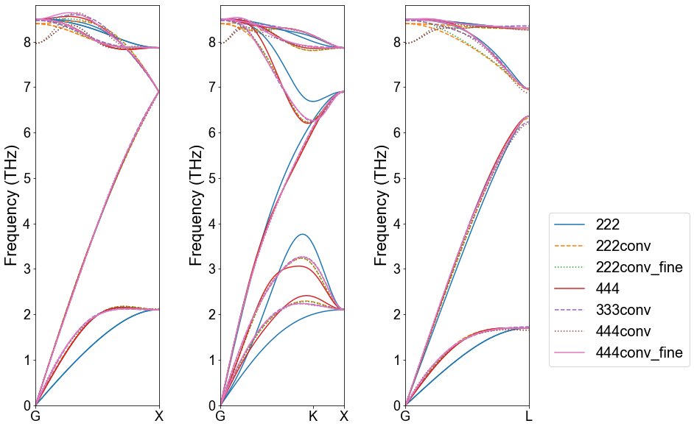

png

**4.1 Anharmonic - convergence w.r.t. cutoff radius and supercell size**

The results of the convergence check with respect to the cutoff radius for the third-order IFC and the supercell size are shown in the table and figures below.

The force constants are calculated with the following methods:

Finite displacements with magnitude of 0.03 Ang.

Full space group symmetry considered

Impose ASR as constraints

Estimate third-order IFCs by ordinary least squares

When fitting the third-order IFCs, the second-order IFCs are fixed to the values obtained in the step 3.

The thermal conductivity calculations are performed with the following conditions:

30x30x30 q points

Use space group symmetry for reducing sampling q points and triplets (q, q‘, q’’)

Tetrahedron method ( ISMEAR = -1 ) for delta function evaluation

Atomic mass : 69.924 u

RTA

no ph-iso scattering, no ph-boundary effects

Phonon group velocity is evaluated as \(\boldsymbol{v}_{\boldsymbol{q}j} \approx (\omega_{\boldsymbol{q}+\Delta\boldsymbol{q}j} - \omega_{\boldsymbol{q}-\Delta\boldsymbol{q}j})/2\Delta\boldsymbol{q}\) where \(\Delta\boldsymbol{q}\) is a small value (~0.001).

Developer Note:For future reference, we have used the new mirror image convention (MIC=1) for third-order IFCs. This option is available only in the develop version of ALAMODE. Only the old convention (MIC=0) is available in the released version of ALAMODE. When the supercell size is 222conv, MIC=1 appears to give a smoother \(r_c\) dependence of \(\kappa_{L}\) than the MIC=0 case. The details of the new convention will be described elsewhere.

|  | SC size IFC2 | SC size IFC3 | Cutoff radius for IFC3 (bohr) | nn shell | # disp. patterns. | Mirror image convention | # irred. IFC3 | kappa_{RTA,pure} (W/mK) | qmesh | node hour (vasp) | node hour (kappa) |  |
| --- | --- | --- | --- | --- | --- | --- | --- | --- | --- | --- | --- | --- |
| 0 | 222conv_fine | 222conv_fine | 4.66573 | 1 | 2 | 0 | 3 | 41.9497 | 30 30 30 | 0.070111 | 0.050000 |
| 2 | 222conv_fine | 222conv_fine | 7.61911 | 2 | 16 | 0 | 27 | 53.8133 | 30 30 30 | 0.785553 | 0.057778 |
| 4 | 222conv_fine | 222conv_fine | 8.93420 | 3 | 16 | 0 | 82 | 57.0099 | 30 30 30 | 0.785553 | 0.095556 |
| 6 | 222conv_fine | 222conv_fine | 10.77500 | 4 | 22 | 0 | 108 | 58.3448 | 30 30 30 | 0.986054 | 0.145556 |
| 8 | 222conv_fine | 222conv_fine | 11.74180 | 5 | 22 | 0 | 197 | 57.1037 | 30 30 30 | 0.986054 | 0.283333 |
| 10 | 222conv_fine | 222conv_fine | 13.19670 | 6 | 36 | 0 | 403 | 50.3056 | 30 30 30 | 1.703464 | 0.815556 |
| 12 | 222conv_fine | 222conv_fine | 13.99720 | 7 | 36 | 0 | 541 | 49.4076 | 30 30 30 | 1.703464 | 1.087778 |
| 14 | 222conv_fine | 222conv_fine | 15.23820 | 8 | 42 | 0 | 647 | 46.5413 | 30 30 30 | 1.903855 | 1.461111 |
| 16 | 222conv_fine | 222conv_fine | 18.66290 | 9 | 45 | 0 | 777 | 49.6683 | 30 30 30 | 1.988652 | 1.906667 |
| 54 | 333conv | 222conv_fine | 4.66573 | 1 | 2 | 0 | 3 | 43.8893 | 30 30 30 | 19.182040 | 0.052222 |
| 56 | 333conv | 222conv_fine | 7.61911 | 2 | 16 | 0 | 27 | 55.2852 | 30 30 30 | 19.897482 | 0.064444 |
| 58 | 333conv | 222conv_fine | 8.93420 | 3 | 16 | 0 | 82 | 59.4980 | 30 30 30 | 19.897482 | 0.101111 |
| 60 | 333conv | 222conv_fine | 10.77500 | 4 | 22 | 0 | 108 | 60.8296 | 30 30 30 | 20.097984 | 0.144444 |
| 62 | 333conv | 222conv_fine | 11.74180 | 5 | 22 | 0 | 197 | 60.6645 | 30 30 30 | 20.097984 | 0.286667 |
| 64 | 333conv | 222conv_fine | 13.19670 | 6 | 36 | 0 | 403 | 52.0562 | 30 30 30 | 20.815394 | 0.821111 |
| 66 | 333conv | 222conv_fine | 13.99720 | 7 | 36 | 0 | 541 | 50.7921 | 30 30 30 | 20.815394 | 1.038889 |
| 68 | 333conv | 222conv_fine | 15.23820 | 8 | 42 | 0 | 647 | 48.1163 | 30 30 30 | 21.015784 | 1.458889 |
| 70 | 333conv | 222conv_fine | 18.66290 | 9 | 45 | 0 | 777 | 51.9249 | 30 30 30 | 21.100581 | 1.905556 |
| 18 | 333conv | 333conv | 4.66573 | 1 | 2 | 0 | 3 | 43.9943 | 30 30 30 | 0.260459 | 0.050000 |
| 20 | 333conv | 333conv | 7.61911 | 2 | 16 | 0 | 27 | 56.5825 | 30 30 30 | 2.568716 | 0.063333 |
| 22 | 333conv | 333conv | 8.93420 | 3 | 16 | 0 | 82 | 60.2724 | 30 30 30 | 2.568716 | 0.114444 |
| 24 | 333conv | 333conv | 10.77500 | 4 | 25 | 0 | 110 | 62.5659 | 30 30 30 | 3.841756 | 0.127778 |
| 26 | 333conv | 333conv | 11.74180 | 5 | 25 | 0 | 199 | 61.6772 | 30 30 30 | 3.841756 | 0.243333 |
| 28 | 333conv | 333conv | 13.19670 | 6 | 45 | 0 | 437 | 60.7980 | 30 30 30 | 7.753127 | 0.548889 |
| 30 | 333conv | 333conv | 13.99720 | 7 | 45 | 0 | 672 | 59.9551 | 30 30 30 | 7.753127 | 0.838889 |
| 32 | 333conv | 333conv | 15.23820 | 8 | 59 | 0 | 879 | 57.5333 | 30 30 30 | 10.103715 | 1.216667 |
| 34 | 333conv | 333conv | 15.93650 | 9 | 59 | 0 | 1353 | 61.4298 | 30 30 30 | 10.103715 | 1.646667 |
| 36 | 333conv | 333conv | 17.03680 | 10 | 72 | 0 | 1886 | 59.1438 | 30 30 30 | 11.974133 | 2.761111 |
| 38 | 333conv | 333conv | 17.66420 | 11 | 72 | 0 | 2233 | 59.2816 | 30 30 30 | 11.974133 | 3.233333 |
| 40 | 333conv | 333conv | 18.66290 | 12 | 80 | 0 | 2447 | 58.4536 | 30 30 30 | 13.417731 | 3.533333 |
| 42 | 333conv | 333conv | 19.23730 | 13 | 80 | 0 | 3106 | 59.5940 | 30 30 30 | 13.417731 | 4.445556 |
| 44 | 333conv | 333conv | 20.15830 | 14 | 101 | 0 | 4598 | 51.3066 | 30 30 30 | 17.167046 | 8.478889 |
| 46 | 333conv | 333conv | 20.69120 | 15 | 101 | 0 | 5768 | 55.3364 | 30 30 30 | 17.167046 | 10.918889 |
| 48 | 333conv | 333conv | 22.85730 | 16 | 107 | 0 | 6822 | 54.6249 | 30 30 30 | 17.856011 | 14.932222 |
| 50 | 333conv | 333conv | 23.32870 | 17 | 107 | 0 | 7406 | 55.5794 | 30 30 30 | 17.856011 | 14.383333 |
| 52 | 333conv | 333conv | 25.26970 | 18 | 116 | 0 | 8578 | 54.9731 | 30 30 30 | 19.111929 | 18.636667 |
| 1 | 222conv_fine | 222conv_fine | 4.66573 | 1 | 2 | 1 | 3 | 41.9497 | 30 30 30 | 0.070111 | 0.050000 |
| 3 | 222conv_fine | 222conv_fine | 7.61911 | 2 | 16 | 1 | 27 | 53.8133 | 30 30 30 | 0.785553 | 0.057778 |
| 5 | 222conv_fine | 222conv_fine | 8.93420 | 3 | 16 | 1 | 82 | 57.0099 | 30 30 30 | 0.785553 | 0.095556 |
| 7 | 222conv_fine | 222conv_fine | 10.77500 | 4 | 22 | 1 | 107 | 59.7641 | 30 30 30 | 0.986054 | 0.121111 |
| 9 | 222conv_fine | 222conv_fine | 11.74180 | 5 | 22 | 1 | 196 | 57.8157 | 30 30 30 | 0.986054 | 0.234444 |
| 11 | 222conv_fine | 222conv_fine | 13.19670 | 6 | 36 | 1 | 395 | 55.1884 | 30 30 30 | 1.703464 | 0.520000 |
| 13 | 222conv_fine | 222conv_fine | 13.99720 | 7 | 36 | 1 | 529 | 56.5767 | 30 30 30 | 1.703464 | 0.708889 |
| 15 | 222conv_fine | 222conv_fine | 15.23820 | 8 | 42 | 1 | 630 | 56.1841 | 30 30 30 | 1.903855 | 0.867778 |
| 17 | 222conv_fine | 222conv_fine | 18.66290 | 9 | 45 | 1 | 743 | 54.2696 | 30 30 30 | 1.988652 | 1.127778 |
| 55 | 333conv | 222conv_fine | 4.66573 | 1 | 2 | 1 | 3 | 43.8893 | 30 30 30 | 19.182040 | 0.051111 |
| 57 | 333conv | 222conv_fine | 7.61911 | 2 | 16 | 1 | 27 | 55.2852 | 30 30 30 | 19.897482 | 0.062222 |
| 59 | 333conv | 222conv_fine | 8.93420 | 3 | 16 | 1 | 82 | 59.4980 | 30 30 30 | 19.897482 | 0.098889 |
| 61 | 333conv | 222conv_fine | 10.77500 | 4 | 22 | 1 | 107 | 62.2392 | 30 30 30 | 20.097984 | 0.128889 |
| 63 | 333conv | 222conv_fine | 11.74180 | 5 | 22 | 1 | 196 | 61.7227 | 30 30 30 | 20.097984 | 0.236667 |
| 65 | 333conv | 222conv_fine | 13.19670 | 6 | 36 | 1 | 395 | 57.4343 | 30 30 30 | 20.815394 | 0.524444 |
| 67 | 333conv | 222conv_fine | 13.99720 | 7 | 36 | 1 | 529 | 59.2178 | 30 30 30 | 20.815394 | 0.695556 |
| 69 | 333conv | 222conv_fine | 15.23820 | 8 | 42 | 1 | 630 | 58.8900 | 30 30 30 | 21.015784 | 0.866667 |
| 71 | 333conv | 222conv_fine | 18.66290 | 9 | 45 | 1 | 743 | 57.3074 | 30 30 30 | 21.100581 | 1.127778 |
| 19 | 333conv | 333conv | 4.66573 | 1 | 2 | 1 | 3 | 43.9943 | 30 30 30 | 0.260459 | 0.050000 |
| 21 | 333conv | 333conv | 7.61911 | 2 | 16 | 1 | 27 | 56.5825 | 30 30 30 | 2.568716 | 0.063333 |
| 23 | 333conv | 333conv | 8.93420 | 3 | 16 | 1 | 82 | 60.2724 | 30 30 30 | 2.568716 | 0.114444 |
| 25 | 333conv | 333conv | 10.77500 | 4 | 25 | 1 | 110 | 62.5659 | 30 30 30 | 3.841756 | 0.125556 |
| 27 | 333conv | 333conv | 11.74180 | 5 | 25 | 1 | 199 | 61.6772 | 30 30 30 | 3.841756 | 0.252222 |
| 29 | 333conv | 333conv | 13.19670 | 6 | 45 | 1 | 437 | 60.7980 | 30 30 30 | 7.753127 | 0.525556 |
| 31 | 333conv | 333conv | 13.99720 | 7 | 45 | 1 | 672 | 59.9551 | 30 30 30 | 7.753127 | 0.831111 |
| 33 | 333conv | 333conv | 15.23820 | 8 | 59 | 1 | 879 | 57.5333 | 30 30 30 | 10.103715 | 1.253333 |
| 35 | 333conv | 333conv | 15.93650 | 9 | 59 | 1 | 1353 | 61.4298 | 30 30 30 | 10.103715 | 1.637778 |
| 37 | 333conv | 333conv | 17.03680 | 10 | 72 | 1 | 1879 | 60.1619 | 30 30 30 | 11.974133 | 2.304444 |
| 39 | 333conv | 333conv | 17.66420 | 11 | 72 | 1 | 2226 | 60.8593 | 30 30 30 | 11.974133 | 2.840000 |
| 41 | 333conv | 333conv | 18.66290 | 12 | 80 | 1 | 2440 | 59.6788 | 30 30 30 | 13.417731 | 2.985556 |
| 43 | 333conv | 333conv | 19.23730 | 13 | 80 | 1 | 3095 | 61.2347 | 30 30 30 | 13.417731 | 3.782222 |
| 45 | 333conv | 333conv | 20.15830 | 14 | 101 | 1 | 4572 | 53.1382 | 30 30 30 | 17.167046 | 5.830000 |
| 47 | 333conv | 333conv | 20.69120 | 15 | 101 | 1 | 5733 | 60.2106 | 30 30 30 | 17.167046 | 8.494444 |
| 49 | 333conv | 333conv | 22.85730 | 16 | 107 | 1 | 6761 | 58.3787 | 30 30 30 | 17.856011 | 8.671111 |
| 51 | 333conv | 333conv | 23.32870 | 17 | 107 | 1 | 7336 | 57.6586 | 30 30 30 | 17.856011 | 9.443333 |
| 53 | 333conv | 333conv | 25.26970 | 18 | 116 | 1 | 8472 | 54.5134 | 30 30 30 | 19.111929 | 11.575556 |

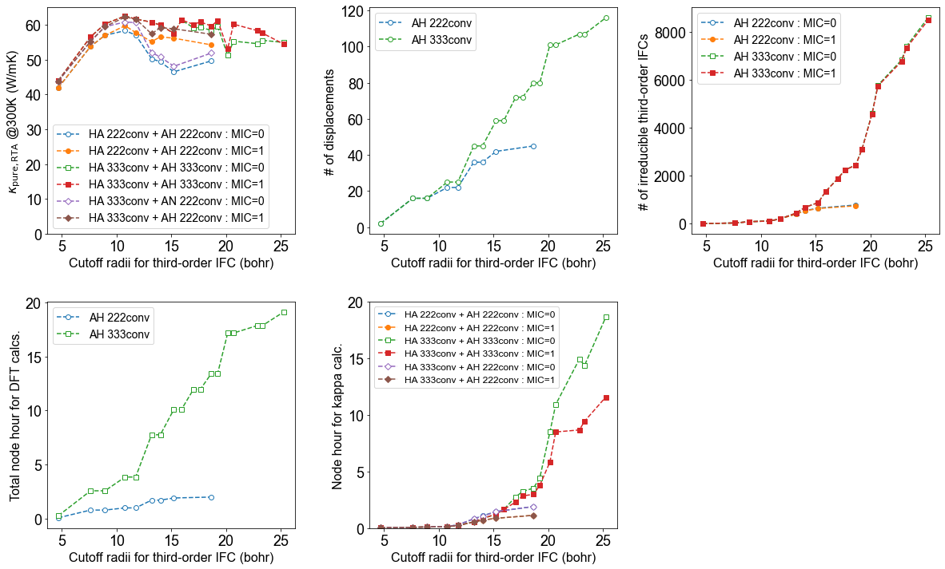

png

**4.2 Anharmonic - convergence w.r.t. q mesh**

The convergence of \(\kappa_{L}\) with respect to the q point density was examined using the following computational conditions:

222conv_fine supercell for second- and third-order IFCs

Mass : 72.63 u (Sorry, this is the standard atomic weight. I should have used 69.924 u instead, but the results are still valid because the purpose here is just to check the convergence.)

\(r_c = 9.0\) bohr for third-order IFCs

3 3

Increase q mesh from 10 to 100

The results below shows that \(\kappa_{L}\) keeps increasing with increasing \(N_q\).

The computational cost increases dramatically (approximately proportional to \(N_q^6\)), but the improvement in the \(\kappa_{L}\) value is very small in \(N_q >50\).

So, we will use \(N_q\) = 50 in the production run.

|  | # q points along each axis | kappa_{RTA,pure} (W/mK) | node hour (kappa) |  |
| --- | --- | --- | --- | --- |
| 0 | 10 | 48.0115 | 0.002222 |
| 1 | 20 | 53.9465 | 0.015556 |
| 2 | 30 | 55.8224 | 0.104444 |
| 3 | 40 | 57.1469 | 0.500000 |
| 4 | 50 | 57.6150 | 1.700000 |
| 5 | 60 | 57.9273 | 4.751111 |
| 6 | 70 | 58.0341 | 11.406667 |
| 7 | 80 | 58.2699 | 24.135556 |
| 8 | 90 | 58.4567 | 47.275556 |
| 9 | 100 | 58.5975 | 85.433333 |

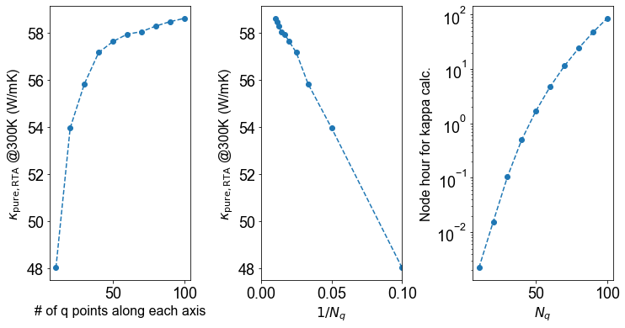

png

**4. Anharmonic - production run**

After checking the convergence of kappa w.r.t. various parameters, I have chosen the following set of parameters for the production calculation.

Lattice constant (Ang.) : 5.7019

ENCUT = 300

SC for IFC2: 333conv

SC for IFC3: 222conv_fine

Cutoff radius for IFC3 (bohr): 9.0 (includes up to 3nn shells)

50x50x50 q points

tetrahedron method for delta function

Mass of Ge: 72.63 u for \(\kappa_{nat}\), 69.924 u for \(\kappa_{pure}\).

isotope factor: 5.86712e–04 for \(\kappa_{nat}\), 0 for \(\kappa_{pure}\)

temperature step: 1 K (1,000 temperature points)

The results of the production calculation are shown in the following tables/figures.

|  | temperature (K) | kappa*{nat, RTA} (W/mK)* | kappa{pure, RTA} (W/mK) |  |
| --- | --- | --- | --- | --- |
| 0 | 10 | 4164.6404 | 81248.4561 |
| 1 | 20 | 1533.4823 | 14143.2884 |
| 2 | 30 | 925.5216 | 5728.8972 |
| 3 | 40 | 678.0002 | 2704.8869 |
| 4 | 50 | 517.7304 | 1439.3737 |
| 5 | 75 | 286.6413 | 508.9327 |
| 6 | 100 | 187.9214 | 281.0113 |
| 7 | 125 | 139.4809 | 191.3812 |
| 8 | 150 | 111.5504 | 145.3769 |
| 9 | 175 | 93.4468 | 117.6502 |
| 10 | 200 | 80.7202 | 99.1177 |
| 11 | 225 | 71.2437 | 85.8260 |
| 12 | 250 | 63.8841 | 75.8013 |
| 13 | 275 | 57.9842 | 67.9526 |
| 14 | 300 | 53.1362 | 61.6288 |
| 15 | 400 | 40.0251 | 45.0969 |
| 16 | 500 | 32.2297 | 35.6675 |
| 17 | 600 | 27.0232 | 29.5387 |
| 18 | 700 | 23.2859 | 25.2241 |
| 19 | 800 | 20.4672 | 22.0174 |
| 20 | 900 | 18.2629 | 19.5384 |
| 21 | 1000 | 16.4905 | 17.5636 |

|  | iq (irred.) | ib | f (THz) | lifetime (ps) | mfp (nm) | multiplicity | modal kappa (W/mK) |  |
| --- | --- | --- | --- | --- | --- | --- | --- | --- |
| 0 | 1 | 1 | 3.289832e–12 | 0.00000 | 0.000000 | 1 | 0.000000e+00 |
| 1 | 1 | 2 | 3.289832e–12 | 0.00000 | 0.000000 | 1 | 0.000000e+00 |
| 2 | 1 | 3 | 3.289832e–12 | 0.00000 | 0.000000 | 1 | 0.000000e+00 |
| 3 | 1 | 4 | 8.469826e+00 | 1.93132 | 0.000000 | 1 | 0.000000e+00 |
| 4 | 1 | 5 | 8.469826e+00 | 1.93132 | 0.000000 | 1 | 0.000000e+00 |
| … | … | … | … | … | … | … | … |
| 18637 | 3107 | 2 | 3.043553e+00 | 12.18500 | 2.549820 | 12 | 4.156040e–07 |
| 18638 | 3107 | 3 | 5.883337e+00 | 1.57527 | 0.374041 | 12 | 6.557070e–08 |
| 18639 | 3107 | 4 | 5.883337e+00 | 1.57527 | 0.374202 | 12 | 6.562700e–08 |
| 18640 | 3107 | 5 | 7.926962e+00 | 1.79782 | 0.014979 | 12 | 8.686780e–11 |
| 18641 | 3107 | 6 | 7.926962e+00 | 1.79782 | 0.015145 | 12 | 8.880470e–11 |

18642 rows × 7 columns

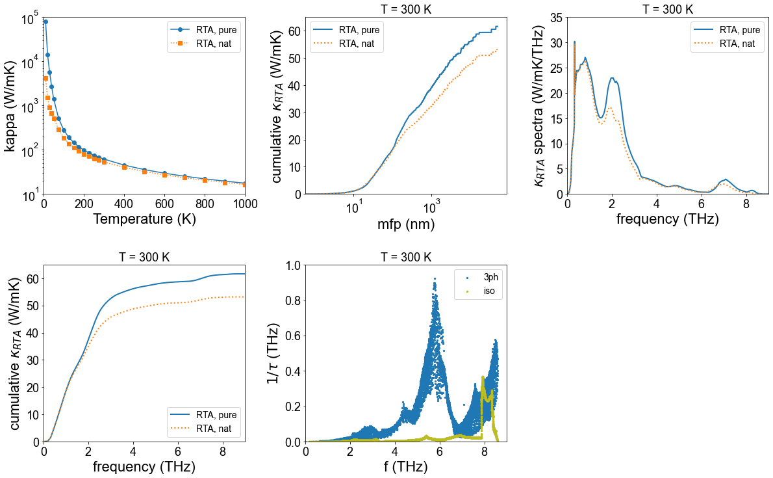

png